

Assignment 1

Object Oriented Analysis/Design

Castiel Li | COMP 3831 | June 8, 2017

# Use Case Model

## LIst of actors

Student: Students can request course catalog, take up to five courses, two addition alternative choices incase class is full or canceled, add or drop courses or change sections.

Instructor: Teach courses (Check which course are they teaching), access to information of students in the class.

Administrator: Schedule course sections for the system.

Billing System: After student register for the course they want, billing system will generate the billing information and sent it to the student.

## Actor – goal list

|  |  |
| --- | --- |
| Actors | Goals |
| Student | - Request course catalog  - Register section  - Register for alternative choices section  - Add, Drop or change section |
| Instructor | - Check sections to teach  - Check student list for the class |
| Administrator | - Input data for course section  - Delete data from system  - Make changes of data in system |
| Billing System | - Generate balance due for student depends the course student registered |

## List of use cases

|  |  |  |  |
| --- | --- | --- | --- |
| Use Case ID | Primary Actor | Use Case Name | Goal |
| UC 1 | Student | Request Course Catalog | System provide information of each course such as instructor, department and prerequisites |
| UC 2 | Student | Register section | System add student to the list for the section he/she desired |
| UC 3 | Student | Delete section | System delete student from the section he/she decide to drop off |
|  |  |  |  |
| UC 4 | Student | Change section | System delete student from the list of the old section and add the same student to the new section he/she desired |
| UC 5 | Instructor | Add Course Section to Teach | System provide the information for all the section and instructor will select the ones she/he will be teaching. |
| UC 6 | Instructor | Check class member information | System provide a list of students who is taking the section that the instructor is teaching |
| UC 7 | Administer | Upload new course | System will take the input and update the database for new course |
| UC 8 | Administer | Delete sections | System will delete the sections of administers choice. (Section has less than 5 students etc) |
| UC 9 | Administer | Change information of an existing course | System will change the information regarding an section by administers needs. |
| UC 10 | Billing system | Sent out billing information | System will have sent out the billing information to student who register for sections |

## Fully dressed use case document

**Name:**

Add Course Section to Teach

**Description:**

An instructor adds a section to teach by the Course ID, Section ID.

**Primary Actor:**

Instructor

**Actors:**

None of other actors involved

**Preconditions:**

System is up and running and the user is authenticated to the system.

**Post-conditions:**

The request is processed

The section is added to instructor’s list

All database related updated

**Main Success Scenario (BASIC FLOW):**

|  |  |
| --- | --- |
| Actor Action | System Response |
| 1. This case begins when an instructor indicates he/she wishes to add one section from one of the course to teach |  |
|  | 2. System Search possible terms |
|  | 3. System display all the terms |
| 4. User Select terms |  |
|  | 5. System search course for the term |
|  | 6. System display course for the term |
| 7. User select course |  |
|  | 8. System search sections for the course |
|  | 9. System display sections for the course |
| 10.User select course section to teach |  |
|  | 11. System save course section for instructor |
|  | 12. System repeat 7-11 as many as needed |

**Extensions (Alternative Flows)**

1. No Section founds

This scenario branches from the main scenario at step 8

If there are no section offered for the course selected

1. System shows a message that there are no sections match the course No: “No section found for the course No you selected, please check again later.”
2. No course founds

This scenario branches from the main scenario at step 3

If there’s no course for the terms user selected

1. System shows a message that the course No does not match any course No in the database: “No course found for the terms you select, please try again later.”

Use Case Diagram:



Instructor Add course section to teach

## UML USE CASE DIAGRAM

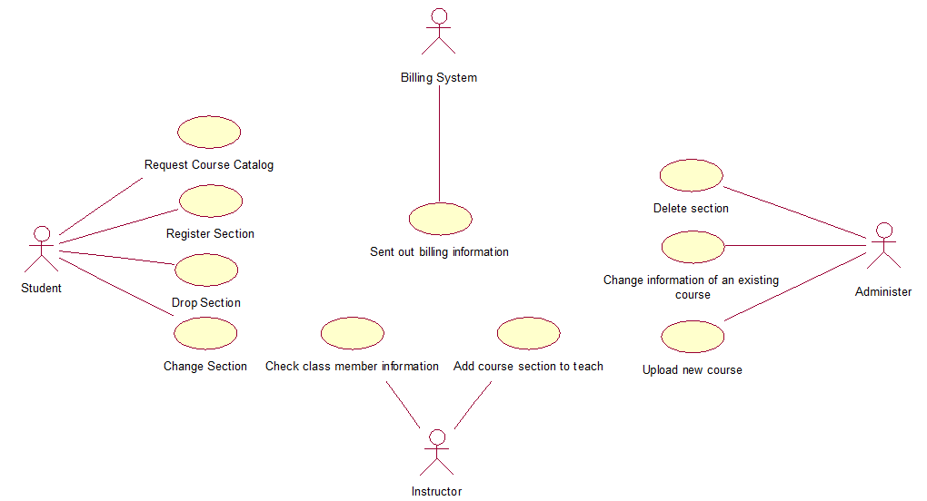

# UML Class diagram

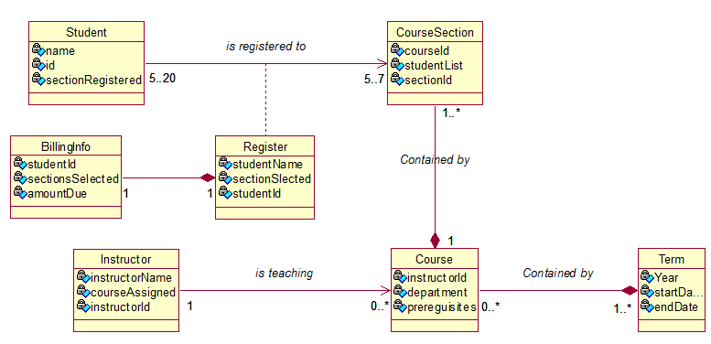

## sEQUENCE DIAGRAm

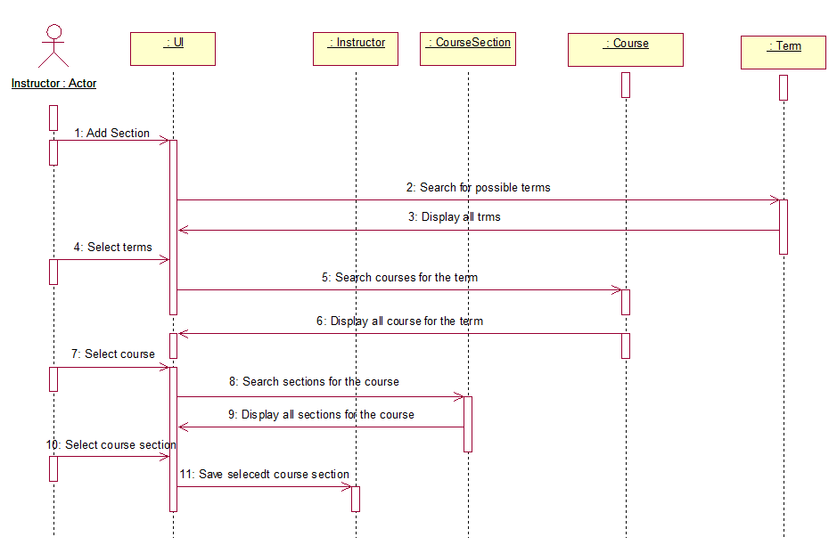

## COLLABORATION DIAGRAM

## C:\Users\casti\AppData\Local\Microsoft\Windows\INetCache\Content.Word\collabration.png